**TUGAS KELOMPOK STRUKTUR DISKRET**

**Tugas Kelompok 1**

Diskusikan dalam kelompok mengenai penerapan **Algoritme Djikstra, Prim,** dan **Kruskal** pada kasus tertentu.

Contoh:

* PT. Telkom ingin mengganti Jaringan Kabel telfon yang sudah ada dengan yang baru. Namun dikarenakan mahalnya penggantian kabel yang menghubungkan 1 wilayah dengan wilayah lain, maka perusahaan akan mennganti kabel telfon dengan jaringan kabel yang menghubungkannya adalah yang paling minimum.
* Pada Kasus ini sebagai Verteks (V) Graph adalah menyatakan wilayah berupa kecamatan misalkan Dramaga dan Cibinong.
* Kemudian sebagai Edge (E), adalah jaringan kabel (panjang jaringan kabel telfon) yang menghubungkan kecamatan Dramaga dan Cibinong.
* Graph G = G(V,E)
* V = {nama kecamatan di Kab Bogor}, contoh A: Dramaga, B: Cibeureum
* E = {Panjang jaringan kabel di Kecamatan di Kab. Bogor}
* Selanjutnya dari ilustrasi tersebut jelaskan solusinya menggunakan salah satu algoritme yang cocok misalnya djikstra, kruskal, dan Prim.

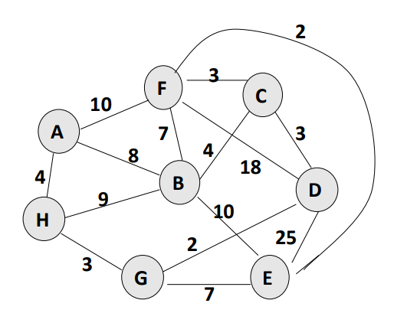

Jawab:

1. Menggunakan solusi algoritma prim dimulai dengan inisialisasi array

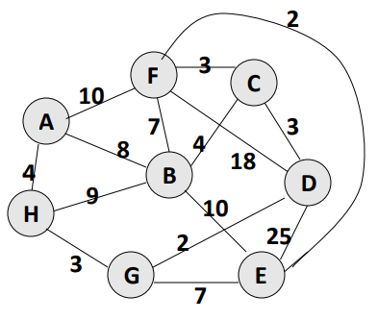

|  |  |  |  |
| --- | --- | --- | --- |
|  | **K** | **dv** | **pv** |
| **A** | S | ∞ | - |
| **B** | S | ∞ | - |
| **C** | S | ∞ | - |
| **D** | S | ∞ | - |
| **E** | S | ∞ | - |
| **F** | S | ∞ | - |
| **G** | S | ∞ | - |
| **H** | S | ∞ | - |

1. Mulai dengan node apa saja, contohnya adalah node D

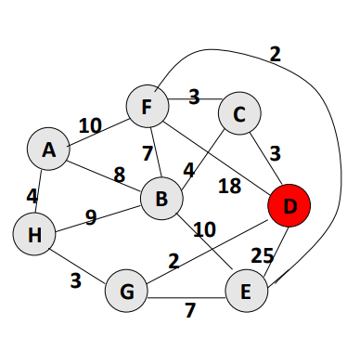

|  |  |  |  |
| --- | --- | --- | --- |
|  | ***K*** | ***dv*** | ***pv*** |
| **A** |  |  |  |
| **B** |  |  |  |
| **C** |  |  |  |
| **D** | B | 0 | - |
| **E** |  |  |  |
| **F** |  |  |  |
| **G** |  |  |  |
| **H** |  |  |  |

1. Pilih node yang memiliki jarak terpendek dengan jarak node yang berdekatan dan node yang tidak dipilih



|  |  |  |  |
| --- | --- | --- | --- |
|  | ***K*** | ***dv*** | ***pv*** |
| **A** |  |  |  |
| **B** |  |  |  |
| **C** |  | 3 | D |
| **D** | B | 0 | - |
| **E** |  | 25 | D |
| **F** |  | 18 | D |
| **G** |  | 2 | D |
| **H** |  |  |  |

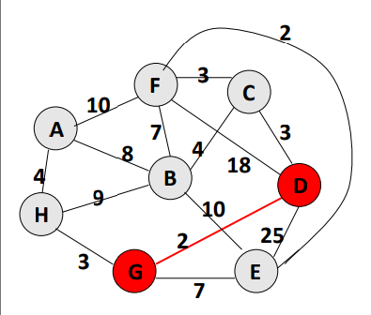

|  |  |  |  |
| --- | --- | --- | --- |
|  | ***K*** | ***dv*** | ***pv*** |
| **A** |  |  |  |
| **B** |  |  |  |
| **C** |  | 3 | D |
| **D** | B | 0 | - |
| **E** |  | 25 | D |
| **F** |  | 18 | D |
| **G** | B | 2 | D |
| **H** |  |  |  |



|  |  |  |  |
| --- | --- | --- | --- |
|  | ***K*** | ***dv*** | ***pv*** |
| **A** |  |  |  |
| **B** |  |  |  |
| **C** | B | 3 | D |
| **D** | B | 0 | - |
| **E** |  | 7 | G |
| **F** |  | 18 | D |
| **G** | B | 2 | D |
| **H** |  | 3 | G |

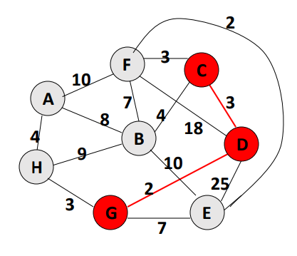

|  |  |  |  |
| --- | --- | --- | --- |
|  | ***K*** | ***dv*** | ***pv*** |
| **A** |  |  |  |
| **B** |  | 4 | C |
| **C** | B | 3 | D |
| **D** | B | 0 | - |
| **E** |  | 7 | G |
| **F** | B | 3 | C |
| **G** | B | 2 | D |
| **H** |  | 3 | G |

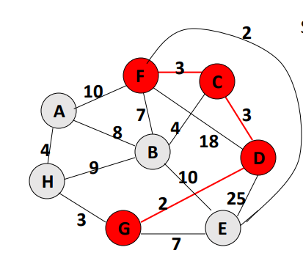

|  |  |  |  |
| --- | --- | --- | --- |
|  | ***K*** | ***dv*** | ***pv*** |
| **A** |  | 10 | F |
| **B** |  | 4 | C |
| **C** | B | 3 | D |
| **D** | B | 0 | - |
| **E** | B | 2 | F |
| **F** | B | 3 | C |
| **G** | B | 2 | D |
| **H** |  | 3 | G |

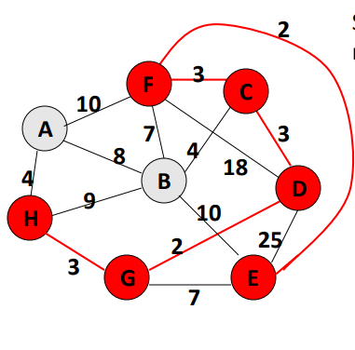

|  |  |  |  |
| --- | --- | --- | --- |
|  | ***K*** | ***dv*** | ***pv*** |
| **A** |  | 4 | H |
| **B** |  | 4 | C |
| **C** | B | 3 | D |
| **D** | B | 0 | - |
| **E** | B | 2 | F |
| **F** | B | 3 | C |
| **G** | B | 2 | D |
| **H** | B | 3 | G |

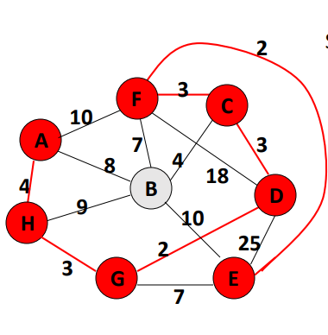

|  |  |  |  |
| --- | --- | --- | --- |
|  | ***K*** | ***dv*** | ***pv*** |
| **A** | T | 4 | H |
| **B** |  | 4 | C |
| **C** | T | 3 | D |
| **D** | T | 0 | - |
| **E** | T | 2 | F |
| **F** | T | 3 | C |
| **G** | T | 2 | D |
| **H** | T | 3 | G |

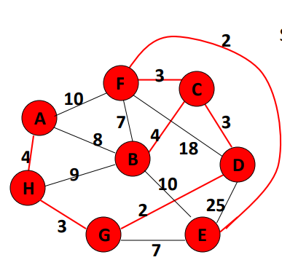

|  |  |  |  |
| --- | --- | --- | --- |
|  | ***K*** | ***dv*** | ***pv*** |
| **A** | T | 4 | H |
| **B** | T | 4 | C |
| **C** | T | 3 | D |
| **D** | T | 0 | - |
| **E** | T | 2 | F |
| **F** | T | 3 | C |
| **G** | T | 2 | D |
| **H** | T | 3 | G |

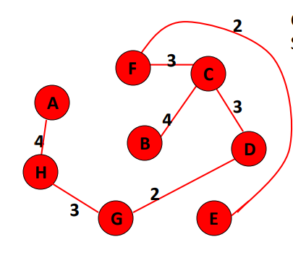

|  |  |  |  |
| --- | --- | --- | --- |
|  | ***K*** | ***dv*** | ***pv*** |
| **A** | T | 4 | H |
| **B** | T | 4 | C |
| **C** | T | 3 | D |
| **D** | T | 0 | - |
| **E** | T | 2 | F |
| **F** | T | 3 | C |
| **G** | T | 2 | D |
| **H** | T | 3 | G |

Spanning Tree = Σ ***dv*** = 4+4+3+0+2+3+2+3 = **21**

**Tugas Kelompok 2**

* Carilah kasus yang serupa seperti pada Tugas Kelompok 1 (bisa dari paper, buku, dan dari sumber lain) yang mempunyai permasalahan terkait dengan optimasi graf atau permasalahan MST.
* Jelaskan permasalahannya, kemudian solusi apa yang dapat selesaikan menggunakan salah satu Algoritme (Kruskal, prim, atau djikstra), buat ilustrasi permasalahan ke dalam sebuah graf, kemudian terangkan dengan langkah terurut penyelesaian solusi dari masalah menggunakan algoritme Djikstra, Prim atau Kruskal.

Contoh soal dari internet : [Sumber](https://athayaniimtinan.blogspot.com/2017/11/minimum-spanning-tree.html)

ada sebuah gedung **Istec Corporation** yang baru memiliki beberapa ruangan dan tiap ruangan membutuhkan 1 lubang aliran listrik (atau biasa disebut sebagai steker). Teknisi listrik akan menyalurkan listrik dari ruang bagian depan sampai keseluruh ruangan dengan total panjang kabel yang seefisien mungkin. Adapun jarak antar ruangan dapat digambarkan dalam gambar jaringan berikut ini.

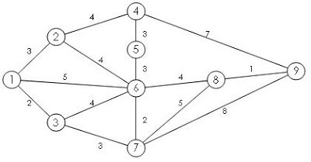

Jawab:

Menggunakan solusi algoritma kruskal.

 Sort the edges by increasing edge weight

|  |  |  |
| --- | --- | --- |
| ***edge*** | ***dv*** |  |
| (8,9) | 1 |  |
| (6,7) | 2 |  |
| (1,3) | 2 |  |
| (1,2) | 3 |  |
| (3,7) | 3 |  |
| (4,5) | 3 |  |
| (5,6) | 3 |  |
| (2,6) | 4 |  |

|  |  |  |
| --- | --- | --- |
| ***edge*** | ***dv*** |  |
| (3,6) | 4 |  |
| (2,4) | 4 |  |
| (6,8) | 4 |  |
| (1,6) | 5 |  |
| (7,8) | 5 |  |
| (4,9) | 7 |  |
| (7,9) | 8 |  |

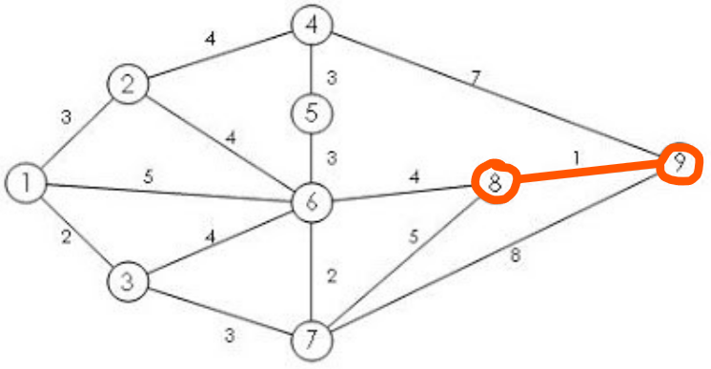Select first |V|-1 edges which do not generate a cycle

|  |  |  |
| --- | --- | --- |
| ***edge*** | ***dv*** |  |
| (8,9) | 1 | v |
| (6,7) | 2 |  |
| (1,3) | 2 |  |
| (1,2) | 3 |  |
| (3,7) | 3 |  |
| (4,5) | 3 |  |
| (5,6) | 3 |  |
| (2,6) | 4 |  |

|  |  |  |
| --- | --- | --- |
| ***edge*** | ***dv*** |  |
| (3,6) | 4 |  |
| (2,4) | 4 |  |
| (6,8) | 4 |  |
| (1,6) | 5 |  |
| (7,8) | 5 |  |
| (4,9) | 7 |  |
| (7,9) | 8 |  |

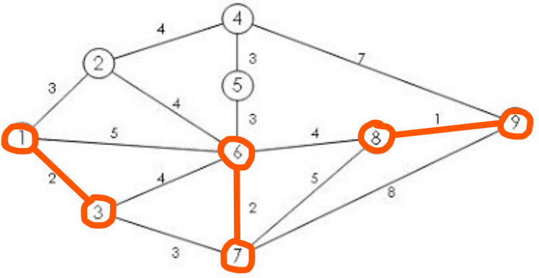Select first |V|-1 edges which do not generate a cycle

|  |  |  |
| --- | --- | --- |
| ***edge*** | ***dv*** |  |
| (8,9) | 1 | v |
| (6,7) | 2 | v |
| (1,3) | 2 | v |
| (1,2) | 3 |  |
| (3,7) | 3 |  |
| (4,5) | 3 |  |
| (5,6) | 3 |  |
| (2,6) | 4 |  |

|  |  |  |
| --- | --- | --- |
| ***edge*** | ***dv*** |  |
| (3,6) | 4 |  |
| (2,4) | 4 |  |
| (6,8) | 4 |  |
| (1,6) | 5 |  |
| (7,8) | 5 |  |
| (4,9) | 7 |  |
| (7,9) | 8 |  |

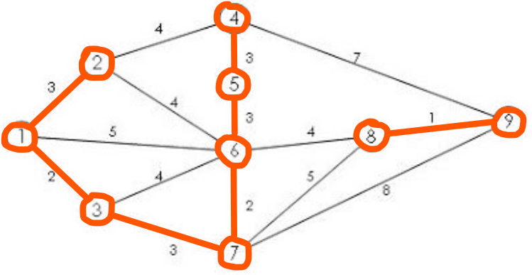

Select first |V|-1 edges which do not generate a cycle

|  |  |  |
| --- | --- | --- |
| ***edge*** | ***dv*** |  |
| (8,9) | 1 | v |
| (6,7) | 2 | v |
| (1,3) | 2 | v |
| (1,2) | 3 | v |
| (3,7) | 3 | v |
| (4,5) | 3 | v |
| (5,6) | 3 | v |
| (2,6) | 4 |  |

|  |  |  |
| --- | --- | --- |
| ***edge*** | ***dv*** |  |
| (3,6) | 4 |  |
| (2,4) | 4 |  |
| (6,8) | 4 |  |
| (1,6) | 5 |  |
| (7,8) | 5 |  |
| (4,9) | 7 |  |
| (7,9) | 8 |  |



Select first |V|-1 edges which do not generate a cycle

|  |  |  |
| --- | --- | --- |
| ***edge*** | ***dv*** |  |
| (8,9) | 1 | v |
| (6,7) | 2 | v |
| (1,3) | 2 | v |
| (1,2) | 3 | v |
| (3,7) | 3 | v |
| (4,5) | 3 | v |
| (5,6) | 3 | v |
| (2,6) | 4 | x |

|  |  |  |
| --- | --- | --- |
| ***edge*** | ***dv*** |  |
| (3,6) | 4 | x |
| (2,4) | 4 | x |
| (6,8) | 4 |  |
| (1,6) | 5 |  |
| (7,8) | 5 |  |
| (4,9) | 7 |  |
| (7,9) | 8 |  |

Accepting edge (2,6), (3,6), (2,4) would create a cycle

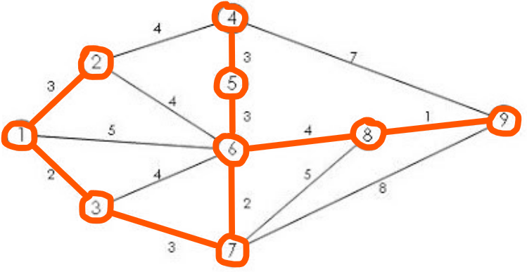 Select first |V|-1 edges which do not generate a cycle

|  |  |  |
| --- | --- | --- |
| ***edge*** | ***dv*** |  |
| (8,9) | 1 | v |
| (6,7) | 2 | v |
| (1,3) | 2 | v |
| (1,2) | 3 | v |
| (3,7) | 3 | v |
| (4,5) | 3 | v |
| (5,6) | 3 | v |
| (2,6) | 4 | x |

|  |  |  |
| --- | --- | --- |
| ***edge*** | ***dv*** |  |
| (3,6) | 4 | x |
| (2,4) | 4 | x |
| (6,8) | 4 | v |
| (1,6) | 5 |  |
| (7,8) | 5 |  |
| (4,9) | 7 |  |
| (7,9) | 8 |  |

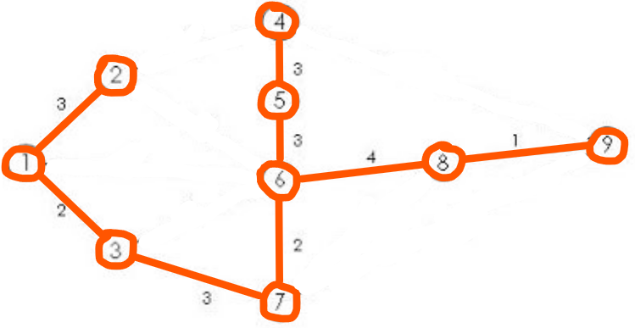 Select first |V|-1 edges which do not generate a cycle

}

Not Considered

|  |  |  |
| --- | --- | --- |
| ***edge*** | ***dv*** |  |
| (3,6) | 4 | x |
| (2,4) | 4 | x |
| (6,8) | 4 | v |
| (1,6) | 5 |  |
| (7,8) | 5 |  |
| (4,9) | 7 |  |
| (7,9) | 8 |  |

|  |  |  |
| --- | --- | --- |
| ***edge*** | ***dv*** |  |
| (8,9) | 1 | v |
| (6,7) | 2 | v |
| (1,3) | 2 | v |
| (1,2) | 3 | v |
| (3,7) | 3 | v |
| (4,5) | 3 | v |
| (5,6) | 3 | v |
| (2,6) | 4 | x |

Done

Total Cost = ∑dv = 21 meter

⁂ panjang kabel yang dibutuhkan adalah **21 meter**, yaitu merentangkan kabel dengan menghubungkan node (1,2), (1,3), (3,7), (4,5), (5,6), (6,7), (7,8), dan (8,9).